The Classification of Eye State by Using kNN and MLP Classification Models According to the EEG Signals

Kadir Sabancı¹, Murat Koklu*²

DOI: 10.1039/b000000x
Abstract: What is widely used for classification of eye state to detect human’s cognition state is electroencephalography (EEG). In this study, the usage of EEG signals for online eye state detection method was proposed. In this study, EEG eye state dataset that is obtained from UCI machine learning repository database was used. Continuous 14 EEG measurements forms the basic of the dataset. The duration of the measurement is 117 seconds (each measurement has14980 sample). Weka (Waikato Environment for Knowledge Analysis) program is used for classification of eye state. Classification success was calculated by using k-Nearest Neighbors algorithm and multilayer perceptron neural networks models. The obtained success of classification methods were compared. The classification success rates were calculated for various number of neurons in the hidden layer of a multilayer perceptron neural network model. The highest classification success rate have been obtained when the number of neurons in the hidden layer was equal to 7. And it was 56.45%. The classification success rates were calculated with k-nearest neighbors algorithm for different neighbourhood values. The highest success was achieved in the classification made with kNN algorithm. In kNN models, the success rate for 3 nearest neighbor were calculated as 84.05%.
Keywords: EEG signals, eye state, weka, multilayer perceptron, kNN classifier

- Introduction
In Classification, training examples are used to learn a model that can classify the data samples into known classes. The Classification process involves following steps: Create training data set, Identify class attribute and classes. Identify useful attributes for classification, Relevance analysis, Learn a model using training examples in Training set, Use the model to classify the unknown data [1].
Measuring brain activity by way of electroencephalography (EEG) can be useful for a lot of applications for which human input is required [2]. Today, Electroencephalography (EEG) eye state classification is a research area in consider. Many studies about EEG signals have been researched and the researches still continue [3].
Fukuda et al. make use of a log-linearized Gaussian mixture neural network for EEG eye state classification [4]. Yeo et al. successfully used support vector machines (SVMs) to detect drowsiness during car driving by eye blink [5]. Moreover, a hybrid system based on decision tree classifier and fast Fourier transform was applied to the detection of epileptic seizure by Polat and Güneş [6]. Sulaiman et all. Also make use of K-nearest neighbour (kNN) for stress features identification [7]. In addition, Hall et all. formed 117- second EEG eye state corpus and employed 42 different machine learnings and statistical approaches based on Weka [8] to predict eye states. Eye state corpus of them is now a benchmark problem saved by Machine Learning Repository, University of California, Irvine (UCI) [9].
_______________________________________________________________________________________________________________________________________________________________
¹ Karamanoglu Mehmetbey University, Faculty of Engineering, ElectricalElectronic Engineering Department, Karaman, Turkey
² Selcuk University, Faculty of Technology, Computer Engineering, Department, Konya, Turkey
* Corresponding Author: Email: mkoklu@selcuk.edu.tr
Note :This paper has been presented at the International Conference on Advanced Technology&Sciences (ICAT'15) held in Antalya (Turkey), August 04-07, 2015.
Wang et all. (2014) applied a promising technique that uses incremental attribute learning (IAL) based on neural networks. IAL is a novel machine learning strategy which gradually imports and trains features one by one. IAL exhibited better classification performance in terms of classification error rates in comparison with conventional and some other approaches [10]. Roesler and Suendermann (2013) applied 42 different machine learning algorithms to the related dataset to predict the eye state after training with the corpus. The best-performing classifier was found as KStar [2].
Sahu et all., (2015) used binary classification for finding feature subset selection named as Incremental Feature Reordering (IFR), it gives most non dominant feature (MND) for Electroencephalography (EEG) signal corpus and create reorder set. They found that the removal of MND gives optimal subset feature and it increases the classifier accuracy and efficiency [11].
Roesler et all. [2014] investigated whether the price of an EEG device is directly correlated with the quality of the obtained data when applied to a simple classification task. The data of three different devices (one medical and two consumer) was used to determine the eye state (open or closed). For classification, 83 machine learning algorithms were used on the raw EEG data. While the cheapest device performed extremely poor with only one classifier better than the majority vote the other two devices achieved high accuracy. The lowest error rate for a more expensive consumer EEG was 1.38% and produced by KStar [12].
Hassani and Lee (2014), proposed Incremental Quantum Particle Swarm Optimization to develop an Incremental Framework for Classification of EEG Signals. They compared the performance of IQPSO against ten other classifiers on two EEG datasets. The results suggested that IQPSO outperformed other classifiers in terms of classification accuracy, precision and recall [13].
Singla et all. (2011) compared SVM with the Artificial Neural Network (ANN) on EEG dataset. A one-against-all SVM and a multilayer ANN is trained to detect the eye events. They presented comparison result in related paper [14]. Razzaghi et all (2015), proposed a multilevel algorithmic framework for SVP that includes (a) construction of hierarchy of large-scale data coarse representations, and b) a local processing of updating the hyper plane throughout this hierarchy. Their multilevel framework substantially improved the computational time without losing the quality of classifiers. Experimental results were presented for balanced and imbalanced classification problems. Quality improvement on several imbalanced data sets had been observed [15].
In this study, EEG eye state dataset at UCI machine learning repository database were used. Classification success rates of the state of eye were determined by using kNN and multilayer perceptron classifiers.
- Materials and Method
2.1. Dataset
EEG Eye State Dataset: All data is from one continuous EEG measurement with the Emotive EEG Neuroheadset. The duration of the measurement was 117 seconds. The eye state was detected via a camera during the EEG measurement and added later manually to the file after analysing the video frames. '1' indicates the eye-closed and '0' the eye-open state. All values are in chronological order with the first measured value at the top of the data. There are 14 attributes and 1 output in the dataset. Total number of the record is 14980 [16].
2.2. Software-WEKA
Weka (Waikato Environment for Knowledge Analysis) written in Java, developed at the University of Waikato, New Zealand [17]. Weka supports several standard data mining tasks, more specifically, data pre-processing, clustering, classification, regression, visualization, and feature selection. All techniques of Weka's software are predicated on the assumption that the data is available as a single flat file or relation, where each data point is described by a fixed number of attributes (normally, numeric or nominal attributes, but some other attribute types are also supported) [18].
2.3. K – Nearest Neighbor Algorithm
K-NN is the supervised learning algorithm, solving the classification problems. Classification is to analyze of features of image, and to belong it to the class which named in advanced. The important thing is determination the features of each category in advance [19]. According to kNN algorithm that was used in classification, characteristics which extracted from classification process, viewing the entire distance among new individual which should be classified and earlier individuals and then the nearest k category is used. As a result of that process test data belongs to the nearest k neighbor category that has more members in certain class. The most important optimization problems in kNN method are identification of neighbor’s number and method of distance calculation algorithm. At the study identification of the optimum k number is done by experiments and Euclidean Distance Calculations method was used as distance calculations method.
Euclidean calculation method [20]:
x_{i} and x_{j} are two different points, and need distance calculation process in between.
2.4. Multilayer Perceptron
A multilayer perceptron (MLP) is a feed forward artificial neural network model that maps sets of input data onto a set of appropriate outputs. A MLP consists of multiple layers of nodes in a directed graph, with each layer fully connected to the next one. Except for the input nodes, each node is a neuron (or processing element) with a nonlinear activation function. MLP utilizes a supervised learning technique called back propagation for training the network. MLP is a modification of the standard linear perceptron and can distinguish data that are not linearly separable [17].
- Results and Discussion
14980 sample data at EEG Eye State Data Set were processed by using Weka program. Classification success for different k neighbour values with kNN algorithm in the state of the eye to be open or closed were obtained. In addition, the root mean square error (RMSE) and the mean absolute error (MAE) values were found. kNN classification algorithm success rates obtained by kNN and MAE and RMSE values is seen in Table 1. The graph showing the variation of MAE and RMSE error values depended on number of neighbourhood in the classification made by kNN algorithm is shown in Figure 1.

Table 1. The success rate and error values obtained by using kNN classifier

Neighbourliness  Number (k) | Classification Success  (%) | MAE | RMSE
1 | 83.6515 | 0.1635 | 0.4043
2 | 81.6021 | 0.1846 | 0.3593
3 | 84.0587 | 0.1993 | 0.3465
4 | 82.9973 | 0.2100 | 0.3410
5 | 83.7917 | 0.2184 | 0.3398
6 | 82.8772 | 0.2263 | 0.3398
7 | 83.3712 | 0.2334 | 0.3419
8 | 82.8371 | 0.2389 | 0.3427
9 | 82.7837 | 0.2441 | 0.3442
10 | 82.4967 | 0.2489 | 0.3454

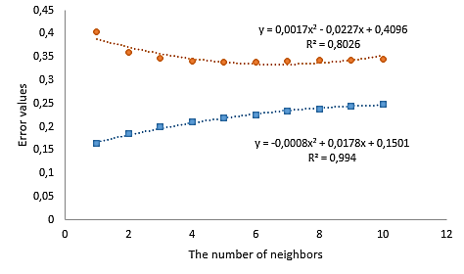
Figure 1. Variation of error rate based on the number of neighbourhood RMSE MAE

The classification success of the state of eye same was obtained by using multilayer perceptron model with the same dataset. The classification success rates at different neurons numbers in the hidden layers and MAE, RMSE error rates were determined. Classification success rates and MAE, and RMSE values obtained by using multilayer perceptron model are seen at Table 2. The number of neurons in the hidden layer 7 when he obtained the highest classification success multilayer perceptron model is shown in Figure 2.
Table 2. Success rate obtained by using Multilayer Perceptron classifier error values

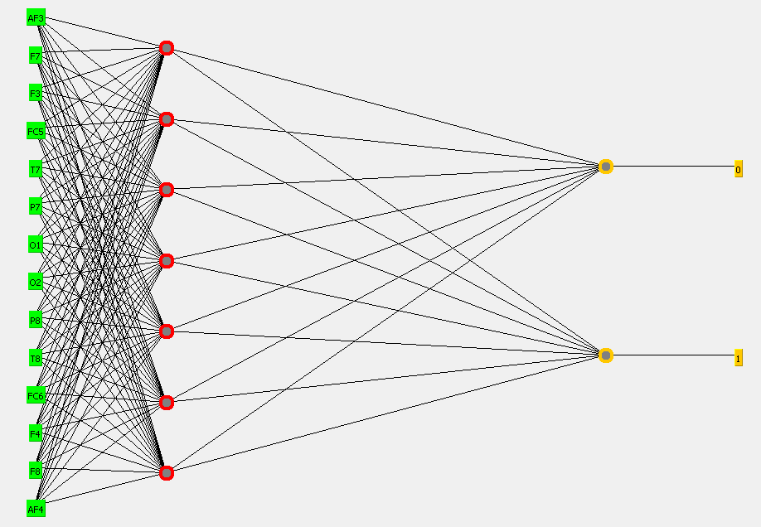
Figure 2. The structure of Multilayer perceptron
- Conclusion
In this study, the datas in EEG State Data Set kNN classifiers and classification success rates of the state of eye were determined by using kNN and multilayer perceptron classifiers. At obtained classification success rates, success rates made with kNN algorithm is seen to be higher. At classification success rates obtained with kNN algorithm, highest classification success was obtained for 3 neighbor values and this value is 84.0587%. At this neighbor value, MAE error value is 0.1993 and RMSE error value is 0.3465.
It is seen that classification success rates obtained by using Multilayer perceptron model is too low for kNN classifier. While the number of neurons in the hidden layer is 7, highest classification success was obtained and this value is 56.4553%. At this neurons number in the hidden layer, MAE error value is 0.1993 and RMSE error value is 0.3465.

References
The number of neurons in the hidden layer | Classification Success  (%) | MAE | RMSE
1 | 54.9332 | 0.4871 | 0.4977
2 | 54.9933 | 0.4873 | 0.4992
3 | 54.9666 | 0.4869 | 0.4988
5 | 54.9466 | 0.4865 | 0.4984
7 | 56.4553 | 0.4775 | 0.4928
9 | 54.9266 | 0.4863 | 0.4980
10 | 54.7397 | 0.4859 | 0.4974
15 | 54.8531 | 0.4865 | 0.4975
20 | 54.8865 | 0.4865 | 0.4976
25 | 54.7931 | 0.4859 | 0.4975
50 | 55.2069 | 0.4835 | 0.4959
- T. C. Sharma and M. Jain, “WEKA Approach for Comparative Study of Classification Algorithm”, International Journal of Advanced Research in Computer and Communication Engineering Vol. 2, Issue 4, April 2013
- O. Roesler and D. Suendermann, “A First Step towards Eye State Prediction Using EEG”. In Proc. of the AIHLS 2013, International Conference on Applied Informatics for Health and Life Sciences, Istanbul, Turkey, September 2013
- T. Wang, S. U. Guan, K. L. Man and T. O. Ting, “EEG eye state identification using incremental attribute learning with time-series classification”. Mathematical Problems in Engineering, 2014
- O. Fukuda, T. Tsuji, and M. Kaneko, “Pattern classification of EEG signals using a log-linearized Gaussian mixture neural network,” inProceedings of the IEEE International Conference on Neural Networks. Part 1 (of 6), pp. 2479–2484, Perth, Australia, December 1995.
- M. V. M. Yeo, X. Li, K. Shen, and E. P. V. Wilder-Smith, “Can SVM be used for automatic EEG detection of drowsiness during car driving?” Safety Science, vol. 47, no. 1, pp. 115–124, 2009.
- K. Polat and S. Güneş, “Classification of epileptiform EEG using a hybrid system based on decision tree classifier and fast Fourier transform,” Applied Mathematics and Computation, vol. 187, no. 2, pp. 327–1026, 2007.
- N. Sulaiman, M. N. Taib, S. Lias, Z. H. Murat, S. A. M. Aris, and N. H. A. Hamid, “Novel methods for stress features identification using EEG signals,” International Journal of Simulation: Systems, Science and Technology, vol. 12, no. 1, pp. 27–33, 2011.
- M. Hall, E. Frank, G. Holmes, B. Pfahringer, P. Reutemann, and I. H. Witten, “The WEKA data mining software: an update,” ACM SIGKDD Explorations Newsletter, vol. 11, pp. 10–18, 2009.
- A. Frank and A. Asuncion, “UCI machine learning repository”, http://archive.ics.uci.edu/ml. 2014.
- T. Wang, S.U. Guan, K.L Man, and T. O. Ting, “EEG Eye State Identification Using Incremental Attribute Learning with Time-Series Classification”, Hindawi Publishing Corporation, Mathematical Problems in Engineering, Volume 2014, Article ID 36532, 9 pages
- M. Sahu, N. K. Nagwani, S. Verma, and S.Shirke, “An Incremental Feature Reordering (IFR) Algorithm to Classify Eye State Identification Using EEG”, Information Systems Design and Intelligent Applications, Advances in Intelligent Systems and Computing Volume 339, 2015, pp 803-811
- O. Roesler, L. Bader, J. Forster, Y. Hayashi, S. Hessler, and D. Suendermann-Oeft, “Comparison of EEG Devices for Eye State Classification”. In Proc. of the AIHLS 2014, International Conference on Applied Informatics for Health and Life Sciences, Kusadasi, Turkey, October 2014.
- K. Hassani and W.S. Lee, “An Incremental Framework for Classification of EEG Signals Using Quantum Particle Swarm Optimization”, Conference: 2014 IEEE International Conference on Computational Intelligence and Virtual Environments for Measurement Systems and Applications (CIVEMSA) DOI: 10.1109/CIVEMSA.2014.6841436
- R. Singla, B. Chambayil, A. Khosla, J, and Santosh, “Comparison of SVM and ANN for classification of eye events in EEG”, J. Biomedical Science and Engineering, 2011, 4, 62-69, doi:10.4236/jbise.2011.41008.
- T. Razzaghi, O. Roderick, I. Safro, and N. Marko, “ Fast Imbalanced Classification of Healthcare Data with Missing Values” . 2015 arXiv preprint arXiv:1503.06250.
- O. Roesler, it12148 '@' lehre.dhbw-stuttgart.de, Baden-Wuerttemberg Cooperative State University (DHBW), Stuttgart, Germany.
- WEKA, http://www.cs.waikato.ac.nz/~ml/weka/ Last access: 10.04.2015.
- R. Arora and Suman, “Comparative Analysis of Classification Algorithms on Different Datasets using WEKA”, International Journal of Computer Applications (0975–8887) Volume 54– No.13, September 2012.
- J. Wang, P. Neskovic, and L. N. Cooper, “Improving nearest neighbor rule with a simple adaptive distance measure”, Pattern Recognition Letters, 28(2):207-213, 2007
- Y. Zhou, Y. Li, and S. Xia, “An improved KNN text classification algorithm based on clustering”, Journal of computers, 4(3):230-237, 2009.

