Classification of Wheat Types by Artificial Neural Network

Ali YASAR¹, Esra KAYA² , Ismail SARITAS²
DOI: 10.1039/b000000x
Abstract: In this study, the types of wheat seeds are classified using present data with artificial neural network (ANN) approach. Seven inputs, one hidden layer with 10 neurons and one output has been used for the ANN in our system. All of these parameters were real-valued continuous. The wheat varieties, Kama, Rosa and Canadian, characterized by measurement of main grain geometric features obtained by X-ray technique, have been analyzed. Results indicate that the proposed method is expected to be an effective method for recognizing wheat varieties. These seven input parameters reaches the 10-neurons hidden layer of the network and they are processed and then classified with an output. The classification process of 210 units of data using ANN is determined to make a successful classification as much as the actual data set. The regression results of the classification process is quite high. It is determined that the training regression R is 0,9999, testing regression is 0,99785 and the validation regression is 0,9947, respectively. Based on these results, classification process using ANN has been seen to achieve outstanding success.
Keywords: ANN, Seed, Classification, Artificial Neural Network, Kama, Rosa Canadian, Machine Learning Database

- Introduction
Nowadays, it is important to choose the appropriate products for agriculture and the cultivation of agricultural products which has great importance for countries. Climatic conditions, the type and the condition of the soil, the types of fertilizer and the chemicals used, the need for watering in the upbringing of the products are important factors. Therefore, it is important to determine the type of the product for its growth. In this research, determination of the wheat type is studied. Classification can be defined simply as an arrangement of objects in groups according to their similarities. In this study, the classification process is realized using ANNs. For wheat type classification process (CTW), classification is realized according
to Seeds data set which can be found in [1]. The examined group comprised kernels belonging to three different varieties of wheat: Kama, Rosa and Canadian, 70 elements each, randomly selected for the experiment. High quality visualization of the internal kernel structure was detected using a soft Xray technique. It is non-destructive and considerably cheaper than other more sophisticated imaging techniques like scanning microscopy or laser technology. The images were recorded on 13x18 cm X-ray KODAK plates. Studies were conducted using combine harvested wheat grain originating from experimental fields, explored at the Institute of Agrophysics of the Polish Academy of Sciences in Lublin. In this study, our purpose is to perform the classification process with the information belonging to our data set using ANN , which is a data mining method.

_______________________________________________________________________________________________________________________________________________________________
¹ Computer Programming, Guneysinir Vocational School of Higher Education Selcuk University Guneysinir, Konya, 42190,Turkey
² Faculty of Technology, Electrical and Electronics Engineering Selcuk University , Konya, 42031,Turkey
* Corresponding Author: Ali YASAR Email: aliyasar@selcuk.edu.tr
- Materials And Methods
In this study, the information from Seeds data set is used which can be found in [1]. The area(A){10,59-21,18}, perimeter(P) {12,41-17,25}, Compactness (C) {0,8081-0,9183} , length of kernel (LK) {4,899-6,675}, width of kernel (WK){2,634,03}, asymmetry coefficient (AC){0,7651-8,456} and length of kernel groove (LKG){4,519-6,55} Wheat type classification is realized with these data and using ANN method. Neural Network Toolbox of Matlab R2013b has been used for this study.

  - Artificial Neural Network:
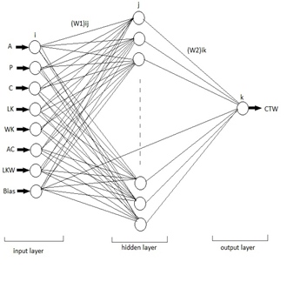
The purpose of ANN, which is a logical programming technique developed by duplicating the mechanism of human brain, is to realize the basic biological operations of human brain using a specific software. ANN is an algorithm which is capable of performing human brain operations, making decisions, producing results, reaching conclusions based on the existing information in case there are insufficient data, continuously receiving, learning and remembering data in a computing environment[2]. ANN is a system which is modelled as an inspiration of biological neural network but with a simpler structure. The main feature of these systems is that they have fully parallel, adaptive, learning and parallel distributed memories[3][4]. Generally, it consists of three layers, i.e. an input layer, one or more hidden layers and an output layer. Each layer has a certain number of components attached to one another called neurons or nodes. Each of the neurons is connected to the other with weights and accompanying communication networks. Signals move through neurons over weights. Each neuron receives multiple inputs from other neurons depending on their weights and generates an output signal that may also be generated by other neurons. [5][6][7] ANNs have their own learning systems as humans. Here, the most repeated networks are the most learning ones. We can examine the learning systems in humans in two groups. The first learning model is supervised self-learning. The second one is unsupervised learning model. In supervised learning model, the resulting data in the intermediate layer for given input data, the transmission of these results to the output layer and acquisition of the net values is necessary for each step of the processes. These processes consist of steps in which the new results are produced from back-propagation of these values. In supervised learning, the data set of the input vectors and the response of the output vectors are used to train the network. The error of the network is found by comparison of the output value belonging to the example and the output value of the network. The weight matrix is updated continuously if the total network error is greater than the acceptable error value. On the other hand, in unsupervised learning, it is required that the network adjust itself with proper weight values so that an output value is produced compatible with the input data set. [8][9] The ANN model which forms our system is shown below, in (Figure.1).
Figure.1 The structure of ANN

As it is seen from the figure, our neural network consists of total 8 inputs as of 7 + 1 inputs, one hidden layer of 10 layers and one output.

  - Application of ANN for A Data Set
In this part, for a data set of 210 units of wheat samples the following processes are performed in order to determine the type of wheat. a. 32 units (15%) of our data have been selected randomly as test data. b. 32 units (15%) of our data have been selected randomly as validation data. c. The remaining 146 units (70%) of our data have been selected as training data. In this study, a feed forward network structure that contains an input layer, a hidden layer and an output layer (Fig. 1) was used. After the ANN structure was designed, the data obtained in the experimental study were normalized in the 0-1 value set using Eq. 1 in order to improve the characteristics of the training. The Back Propagation algorithm was used in the training procedure. Different transfer functions (Purelin, Tansig, Logsig etc.) were used and tried in the neurons in the hidden and output layers and (Tansig) was selected as the transfer function that yielded the best result.

(1)

The training data set was used to determine ANN neuron and bias weight values. Training was repeated to obtain the lowest level of error by changing the number of neurons and the epoch number. Then, the trained algorithm was applied on the test data set. Initially, the network was trained by using different values in the hidden layer and according to the results, it has been observed that better results were obtained for the 10-neurons hidden layer. At the end of these procedures, the network structure that yielded the best classification is given in Table 1.

Table 1. The parameters and properties used in ANN
Parameters | Properties
Number of neurons in the input layer | 7
Number of the hidden layers | 1
Number of neurons in the hidden layer | 10
Number of neurons in the output layer | 1
Learning rate (α) | 0,3
Coefficient of momentum (β) | 0,3
Learning algorithm | Gradient descent (traingd)
Transfer function | Logarithmic sigmoid (logsig)

As a result of the training, the regression graph of the training set is shown in Figure.2.
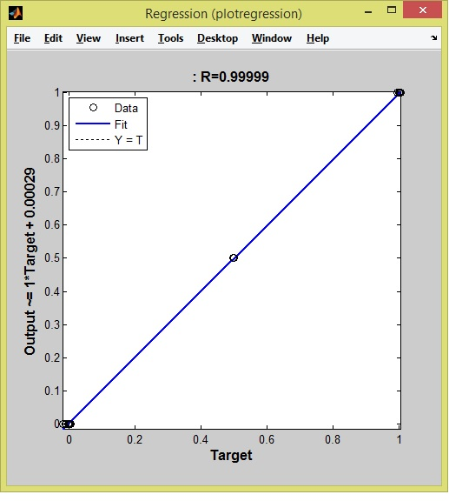
Figure.2 Train Set Regression

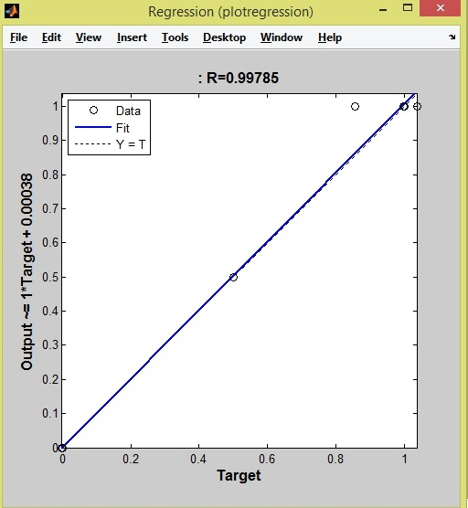
The regression graph of the testing set is shown in Figure.3.
Figure.3 Test Set Regression
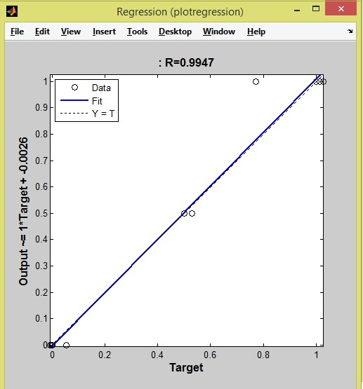
The regression graph of the validation set is shown in Figure.4.
Figure.4 Validation Set Regression
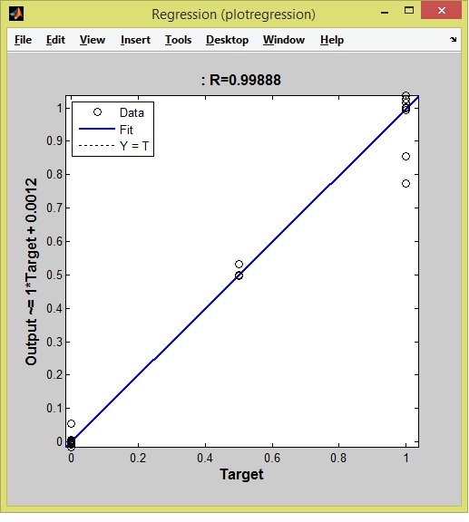
The regression graph of the output is shown in Figure.5.
Figure.5 Output Set Regression

- Result and Discussion
The comparison of experimental measurement values for CTW test data set and ANN estimation values are shown in Figure.6. All the randomly selected data used for test is different than the data used for training process.

Figure.6. Data Set Result / ANN Predict
The comparison of experimental measurement values for CTW validation data set and ANN estimation values are shown in Figure. 7. All the randomly selected data used for validation is different than the data used for training process.

Figure.7. Validation Result / ANN Predict
Lastly, the values obtained from the remaining data, which are the estimation results of the artificial neural network (ANN), is shown in Figure.8.

Figure.8. Train Result / ANN Predict
As seen in the figures, the estimation results and dataset results are almost overlapping. The deviation between experimental and estimated results is very small and negligible for any CTW performance.

- Conclusions
In this study, it is seen that using ANN for classification processes could yield great results. Looking at the results obtained, better results have been obtained than [10]. M. Charytanowicz and his friends have reached a classification success rate between %92 and %96. On the other hand, it is seen that our study's success rate is %99 and above.

Acknowledgements
Contributors gratefully acknowledge support of their work by the Institute of Agrophysics of the Polish Academy of Sciences in Lublin and http://archive.ics.uci.edu/ml/index.html . This study has been supported by Selcuk University’s Scientific Research Unit (BAP).

- References

[1] UCI Machine Learning Repository ( Center for Machine Learning and Intelligent Systems http://archive.ics.uci. edu/ml/datasets.html).
[2] Civalek, Ö., “Nöro-Fuzzy Tekniği ile Dikdörtgen Plakların Analizi”, III. Ulusal Hesaplamalı Mekanik Konferansı, 16-18 Kasım, İstanbul, 1998, 518-524.
[3] Yüksel Özbay, “EKG Aritmilerini Hızlı Tanıma”, Doktora Tezi, 1999
[4] Ömer KELEŞOĞLU, Cevdet Emin EKİNCİ, Adem FIRAT, The Using Of Artificial Neural Networks In Insulation Computations, Journal of Engineering and Natural Sciences Mühendislik ve Fen Bilimleri Dergisi Sigma/2005-3
[5] Cinar, M. , Engin, M. , Engin, E.Z. & Ates, Y.Z. (2009). Early Prostate Cancer Diagnosis by Using Artiﬁcial Neural Networks. Expert Systems with Applications, 6357–6361.
[6] Lorenz, A., Blum, M., Ermert, H., & Senge, Th. (1997). Comparison of Different Neuro-Fuzzy Classification Systems for the Detection of Prostate Cancer in Ultrasonic Images. Ultrasonics Symposium, 2,1201-1204.
[7] Ronco, A.L., & Fernandez, R. (1999). Improving Ultrasonographic Diagnosis of Prostate Cancer with Neural Networks. Ultrasound in Med. & Biol., vol. 25, no. 5, pp. 729– 733
[8] Dias W.P.S., Pooliyadda S.P. “Neural Networks for Predicting Properties of Concrete with Admixtures”, 2001
[9] Özsoy İ., Fırat M. “Kirişsiz Döşemeli Betonarme Bir Binada Oluşan Yatay Deplasmanın Yapay Sinir Ağları İle Tahmini” 2004 [10] M. Charytanowicz, J. Niewczas, P. Kulczycki, P.A. Kowalski, S. Lukasik, S. Zak, 'A Complete Gradient Clustering Algorithm for Features Analysis of X-ray Images', in: Information Technologies in Biomedicine, Ewa Pietka, Jacek Kawa (eds.), Springer-Verlag, Berlin-Heidelberg, 2010, pp. 1524

