Distinct Features for Detection of Pigment Epithelial Detachment using Machine Learning and Artificial Neural Network in Two-Dimensional Optical Coherence Tomography Images
Sheeba T. M.*¹, Albert Antony Raj S.²

Submitted: 09/12/2023 Revised: 20/01/2024 Accepted: 30/01/2024
_______________________________________________________________________________________________________________________________________________________________________________________________________________________________________________________________________________________________________________________________
¹ Department of Computer Applications, Faculty of Science & Humanities, SRM Institute of Science and Technology, Kattankulathur, India.
ORCID ID : 0000-0002-0114-6752
² Department of Computer Applications, Faculty of Science & Humanities, SRM Institute of Science and Technology, Kattankulathur, India.
ORCID ID : 0000-0003-0363-4247
* Corresponding Author Email: st3121@srmist.edu.in
Abstract: Eye is the very important sense organ of the human body. Retinal diseases affect the normal people. Some of the retinal diseases are Macular hole, Macular Edema, Central series Retinopathy, Diabetic Retinopathy, Pigment Epithelial Detachment (PED) and Age Related Macular Degeneration (ARMD). Two types of Imaging techniques used to diagnose the Retinal diseases such as Fundus images and Optical coherence tomography (OCT) images. OCT is an imaging technique to provide high resolution images to accurate diagnose the Retinal diseases. PED is the one of the retinal diseases that found in the Retinal Pigment Epithelium(RPE) layer. The RPE layer is Elevated and forms arc shape due to PED. In this paper proposed to detect the PED using machine learning algorithms such as SVM (Support Vector Machine), Decision Tree(DT), Logistic Regression(LR), K- Nearest Neighbor (KNN) Classifiers and Artificial Neural Network(ANN). We used around 100 images taken from the OCT (Optical Coherence Tomography) modality and having similar properties. We proposed four novel features such as Maximum-Left-Height, Number-of-Left-Down-Points, Number-of-Right-Down-Points, and Maximum-Right-Height. For implementation process we used PYTHON and MATLAB. OCT images are affected by speckle noise. To remove the speckle noise we used Wiener filtering technique. In the segmentation process, to extract the RPE layer we used thresholding technique. Then these extracted features were used to train the machine learning algorithms and test the model for new input. Then, we calculated the metrics such as accuracy, sensitivity, specificity, precision and F1-score of the SVM, DT, LR, KNN classifiers and we also analysed ANN algorithm such as Back Propagation Neural Network (BPNN) and compared with the machine learning classifiers. The overall results demonstrate that the LR system has produced high accuracy. LR for 95% accuracy, 100% sensitivity, 90% specificity, 90% precision and 95% F1-score.
Keywords: Artificial Neural Network, Optical Coherence Tomography, Pigment Epithelial Detachment, Retinal Pigment Epithelium Layer, Machine Learning Classifiers.

- Introduction
Human vision is a highly complex activity and it is the main source of the normal people. The major parts are eyes are cornea which covers the front side of the human eye, Retina which is the light sensitive thin layer located in the back side of the eye, pupil of eye is the black hole in the middle of the iris, Iris is the colored part of the eye, Lens are focus light to create a sharp images, and nerve connect to the path from eye to brain. The sample image for eye is as shown in Fig. 1.
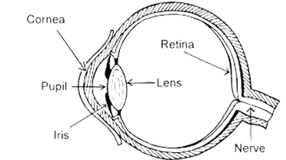
Fig. 1. Human Eye
Optical coherence tomography (OCT) was first established in 1991 by Huang et al.[1]. Age-related macular degeneration (ARMD), glaucoma, diabetic retinopathy, macular edema, Central series retinopathy and PED are a few of the ocular illnesses that diagnosed with OCT. In comparison to Fundus, OCT offers various benefits, including a high clarity, accurate volumetric imaging of the retina and the appearance of other detailed functional structure. The sample healthy OCT images as shown in Fig. 2.
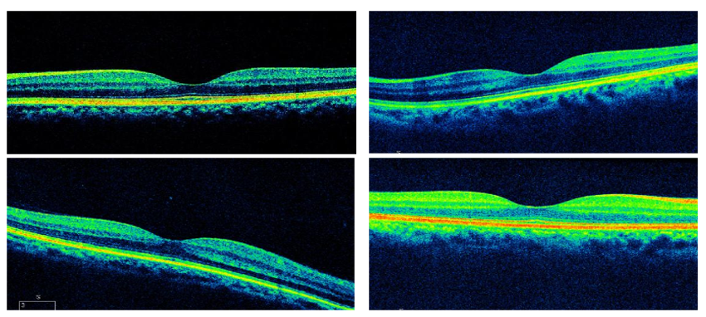
Fig. 2. Normal OCT images
The human eye contains 11 layers and can be viewed with the help of OCT imaging. There are Nerve Fiber Layer(NFL), Ganglion Cell Layer(GCL), Inner Plexiform Layer(IPL), Inner Nuclear Layer(INL), External Limiting Membrane(ELM), Inner Photoreceptor (ISPR), Outer Nuclear Layer (ONL), Outer Plexiform Layer (OPL), Choroid, Outer Photoreceptor (OSPR) and Retinal Pigment Epithelium Layer (RPE). The retinal layers mentioned in Fig. 3.
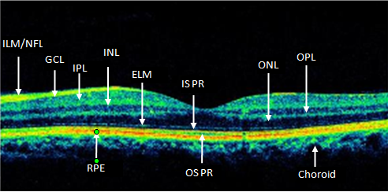
Fig. 3. Retinal layers in OCT image
The retinal disorder includes PED, polypoidal choroidal vasculopathy, central serous chorioretinopathy, and AMD[2][3]. PED causes blurry vision, dark shadow and partially loss of vision. Finally, PED can affect the central vision[4][5]. PED is located at the Retinal Pigment Epithelium (RPE) layer. PED may generally be divided into three categories: serous, drusenoid, and fibrovascular. There are numerous significant variances in the clinical and prognosis characteristics of the three forms of PED, despite the fact that they have certain fundamental commonalities. As illustrated in Fig. 4, the serous PED area is situated among the Bruch Membrane(BM) and the RPE floor and has a smooth, arch-like structure with RPE distortion. For the analysis and managing the pertinent retinal illnesses, measurable data about serous-PED, involving correct boundaries, size, location is crucial. The therapeutic importance of automated segmentation of serous-PED substances in OCT is therefore significant. Automatically segment aberrant retinal anomalies is yet a difficult challenge. For this work, there are four major steps such as preprocessing, RPE layer segmentation, novel feature extraction and PED classification using machine learning classifiers such as SVM, DT, LR, KNN and ANN.
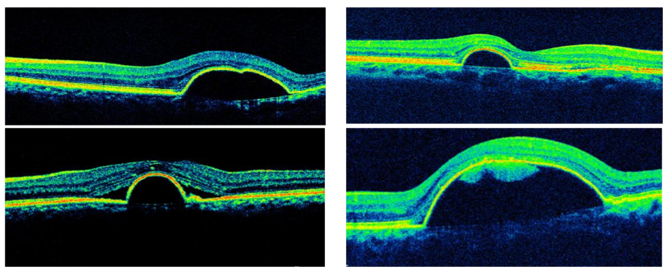
Fig. 4. Abnormal retinal OCT images
The first step in the proposed methodology is preprocessing, which is used to denoising the OCT image. OCT images are captured with speckle noise. The speckle noise degrades the image quality, so it should be removed using filtering techniques. We used the wiener filtering technique to reduce speckle noise, because wiener filter gave best performance when compared with the other filtering techniques such as median, mean(average), bilateral and Gaussian based on the metrics Peak Signal to Noise (PSNR), Contract to Noise (CNR), Mean Square Error (MSE) values. In the second step, the RPE layer is segmented. In the RPE layer segmentation we used thresholding method. In the third step, we extracted the features from the RPE layer. There are four novel features such as Maximum-Left-Height, Number-of-Left-Down-Points, Number-of-Right-Down-Points, and Maximum-Right-Height, were extracted. In the fourth step, these extracted features were used to train the machine learning algorithms and test the model for the new input to detect PED. The machine learning classifiers used here are SVM , DT, LR, KNN and ANN to predict the PED images as normal and abnormal, then we analysed the metrics accuracy, sensitivity, specificity, precision and F1-score.
- Literature Review
Age-related macular degeneration (AMD) is the most frequent chorioretinal disease process that has the characteristic of retinal pigment epithelial detachment (PED)[6][7]. The assessment of these PEDs using planar imaging techniques like colour fundus photography and fluorescein angiography was the only focus of the early research. These preliminary investigations showed that PEDs could change over time and that it might be crucial to detect and categorise PEDs. For instance, some researchers found that the existence of long-term avascular PEDs may be linked to a bad prognosis and may be linked to the advancement of vascularized PEDs over time[8][9]. More accurate and thorough evaluation of PEDs is now possible thanks to the advancement of cross-sectional imaging methods. Numerous researchers have reported that serous, drusenoid, and fibrovascular PEDs may all be seen and distinguished on SD-OCT imaging [10]-[14]. Using traits including size, curvature, and internal reflectivity, several organisations have further discovered and categorised a range of drusenoid PED subtypes[15]. However, few studies have tried to investigate different fibrovascular PED subtypes or to ascertain if OCT can consistently detect the early indications of fibrovascular infiltration. They found that PEDs with occult choroidal neovascularization (CNV) on angiography and apparent fibrovascular infiltration on OCT were correlated[16]. However, in the earlier research, fibrovascular PEDs were not automatically identified and quantified; instead, reading centre professionals performed a thorough human segmentation process to identify and quantify them[17]. The automated quantitative information that OCT gives has been a key factor in its quick and widespread adoption in retinal clinical practice. Prior to now, the majority of commercial OCT software's automated assessments could only quantify the thickness of the retinal or nerve fiber layer. The researchers and OCT producers have recently shown algorithms that can accurately segment and measure increases in RPE in individuals with AMD and associated conditions[12][17][18]. Notwithstanding these advancements, there hasn't been much work done to automatically categorise these regions of RPE increase and pinpoint PEDs that may have early subclinical fibrovascular infiltration.
- Methodology
The block diagram of the proposed system is shown in Fig. 5. The OCT image is the input to the proposed system. The proposed system consists of four sections. They are denoising the image, RPE layer segmentation, novel feature extraction and PED detection. In PED detection we analysed the following machine learning classifiers: SVM, LR, K-NN, DT and also we analysed ANN algorithm such as Back Propagation Neural Network (BPNN).
  - Preprocessing
Initially, the source image is given to the preprocessing step, which includes greyscale conversion and noise reduction. The OCT
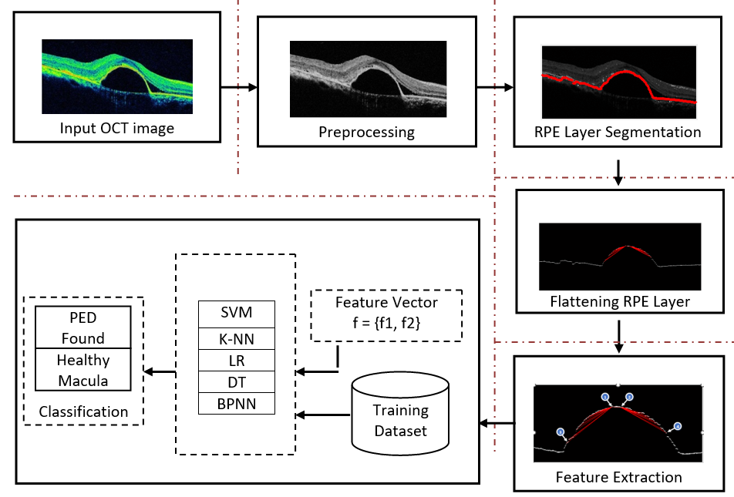
Fig. 5. Proposed system
images are captured with speckle noise. Speckle noise degrades the image quality, so we removed the speckle noise using the filtering technique to improve the accuracy. Homomorphic-filters were applied to remove or decrease these noises in order to remove the speckle noises. Although there are many other filters, homomorphic filters are favored in preprocessing because to the cumulative identity of the find the noises, namely, speckles. Following preprocessing, a method of segmentation is used to advance the operation in order to extract the retinal layers [18]-[20]. This makes sure that the retinal layers of interest are separated from the unnecessary background so that they may be processed separately. Reduce Speckle Noise and RPE Layer Segmentation were the two methods employed for the preprocessing stage [21] [22] [24]-[31]. Wiener filters were employed in the initial stages of preprocessing to greatly reduced the speckle noise[23]. In this section, we analysed median, mean(average), bilateral, Gaussian and wiener filtering techniques. Based on the evaluation metrics Peak Signal to Noise(PSNR), Contract to Noise(CNR) and Mean Square Error(MSE) values, wiener filtering technique significantly reduce the speckle noise. The Fig. 6 shows the original OCT image, grayscale image and filtered image. The Fig. 7 shows the analysis of the filtering techniques based on the metrics PSNR, CNR and MSE.
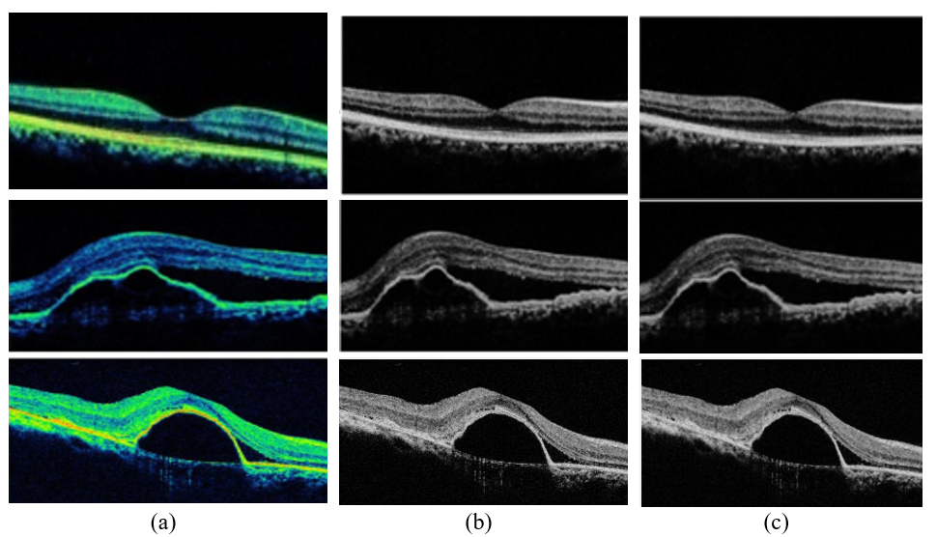
Fig. 6. (a) Normal Images (b) Gray scale images (c) Filtered images

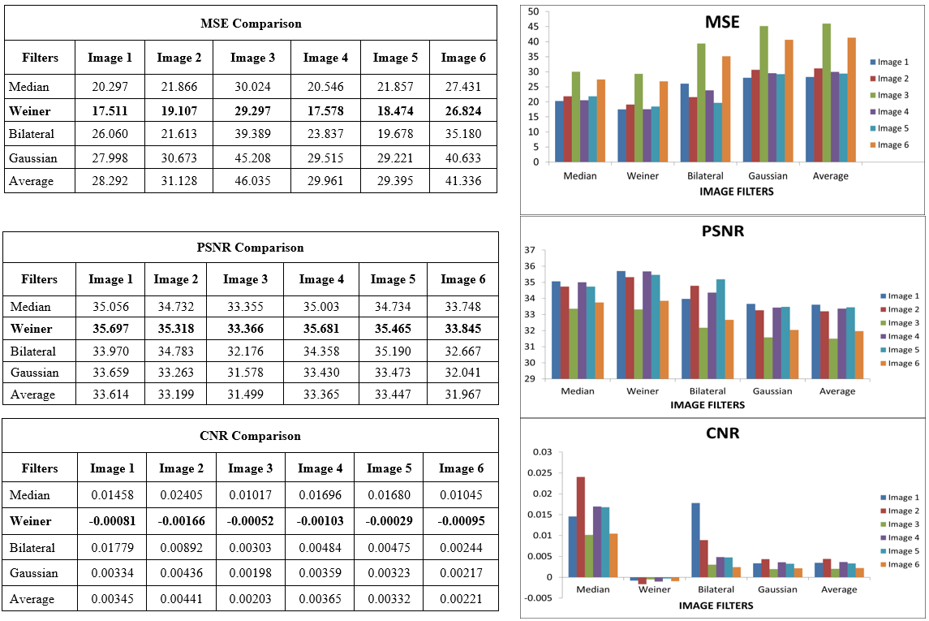
Fig. 7. Analysis of filtering techniques base on MSE, PSNR and CNR metrics

  - RPE Layer Segmentation
The bottom layer of the OCT image is called as RPE layer. RPE layer is the smooth and brightness layer which is extracted and it can be analysed to diagnose PED diseases. The RPE layer extraction technique in the OCT images is important for the diagnosis of ocular and systemic diseases. The thresholding method is used to extract RPE layer. In this method, to extract the RPE layer out each last bright pixel in each column is chosen. As a result, the final pixel of each column produces well-defined curve shape. The RPE surface formed by choosing only the end pixels in every column. The segmented RPE layer is shown in Fig. 8. The thresholding T is calculated as:
$T=T[x,y,p\left(x,y\right),f\left(x,y\right)]$ (1)
Where T is threshold, p(x, y) and f(x, y) are greyscale image. The thresholding functions g(x, y) is defined as:
$g\left(x,y\right)=\left\{\begin{aligned}1 if f\left(x,y\right)>1 \\ 0 if f\left(x,y\right)≤0\end{aligned}\right.$ (2)
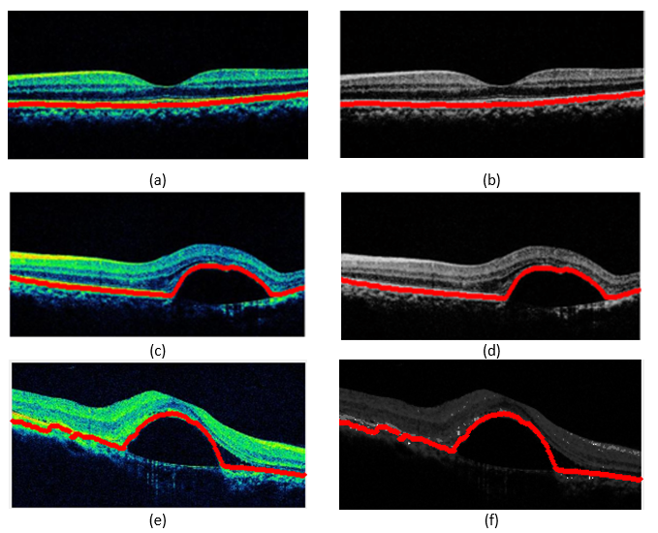
Fig. 8. (a) Healthy image with RPE layer, (b) RPE layer on healthy grayscale image, (c) and (e) RPE layer on PED image, (d) and (f) RPE layer on gray scale image with PED
  - Feature Extraction
Feature extraction is the significant step in the image processing. It is important to focus on the feature extraction stage as it has an observable impact on the effectiveness of the recognition system. It is used to detect features in digital images such as edges, curves, shapes, texture, colors or motion. Once these are identified, the data can be processed to perform various tasks related to analyzing an image. In PED images, feature extraction is done after denoising the image and RPE layer segmentation. Feature extraction is applied to the segmented OCT images, then followed by classification. As a consequence, rather than examining the complete image data for further processing, the output is projected to deliver a clear view of the necessary RPE layer with PED based anomalies. In this work, four features were chosen from the segmented RPE layer. The distinct features include Maximum-Left-Height(MLH), Number-of-Left-Down-Points (NLDP), Number-of-Right-Down-Points (NRDP), and Maximum-Right-Height(MRH). These features were used as input data to the categorization of the images as normal and anomalous. Fig. 9 shows the extracted features in the segmented RPE layer.
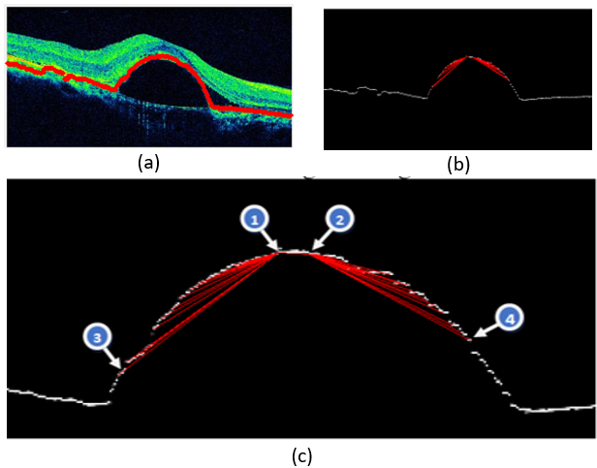
Fig. 9. (a) RPE layer on original image with PED, (b) Segmented RPE Layer (c) Extracted features: 1 Maximum-Left-Height, 2 Maximum-Right-Height, 3 Number-of-Left-Down-Point and 4 Number-of-Right-Down-Point
Here, the formulae to determine the layer's top, bottom, and maximum height are given as:
$t=min(L_{j}$) (3)
$b=\max\left(L_{j}\right)$ (4)
$mHgt=b-t$ (5)
where x runs from 0 to the width of the picture, and Lj is the y axis value for each x value on the RPE layer. The min() function is used to get the RPE layer's minimum y axis value in order to determine the layer's top since the top left coordinate of the image is (0, 0). The max() function is used to determine the lowest layer. The line's highest point is reached by iterating the line from 0 to the top left point. The top right point is obtained by repeatedly moving from the predicted top left point to the line's highest point. Then, 16 points are extracted from the top left point to create a bounding rectangle. The breadth of the rectangle depends on the retinal layer's height.
$w=mH$ (6)
In order to find the curve in this study, 16 points were taken from the top left point and 16 points from the top right point. To extract 16 points from the top-left point, the distance is calculated as follows:
$dis=w/16$ (7)
The line points are then iterated 16 times backward from the top left point to determine the line height of each point:
${lPs}_{j }=mHgt-( L_{(topLPoint-dis*j)})$ (8)
where j varies from 1 to 16
The following equation extracts the top right 16 points:

${rPs}_{j}=mHgt-(L_{(topRPoint+dis*j)})$ (9)
where j varies from 1 to 16
The left height (LH) and right height (RH) characteristics are extracted using the following equations:
$LH=max({lPts}_{j})$ (10)
$RH=max({rPts}_{j})$ (11)
The left down points (LDP) characteristic is then calculated by comparing the successive leftPoints. If a left point value is less than the left point value after it, increase the counter LDP. The right down points (RDP) characteristic is calculated by comparing the rightPoints and raising the counter.
$LDP=LDP+1$ $if( {lPts}_{j}<{lPoints}_{(j+1})$ (12)
$RDP=RDP+1$ $if( {RPts}_{j}<{RPoints}_{(j+1)})$ (13)
Algorithm Ext_Feature(Layer)
Input: Layer – Extracted RPE layer in an array
Output: Extracted Features
1. t = min(Layer), b = max(Layer)
2. lineHgtj = b – Layerj;
3. mHgt = b - t;
4. Do line-5 for j=1 to length(Layer)
5. if (lineHgtj = mHgt) goto line-6
6. topLPnt = j
7. w = mHgt
8. Pts=16
9. dist = w / Pts;
10. lPts(1)=mHgt;
11. Do line-12 and line-13 for k=1 to Points
12. pos = topLPoint – distBtwnPts * j;
13. lPts(j+1)=lHgt(pos);
14. Do line-15 for k = j to length(lneHgt)
15. if (lneHgt(k) <> mHgt) goto line-16
16. topRPnt = k;
17. rPts(1)=mHgt;
18. Repeat line-19 and line-20 for m =1 to Pnts
19. pos=topRPoint + distBtwnPts * m
20. rPts(m+1) = lneHgt(pos)
21. LH = max(lHgt)
22. RH = max(rHgt)
23. LDP=0, RDP=0
24. Do line-25 to line-28 for j = 2 to Pts
25. if ((lHgtj-lHgtj-1)>0)
26. LDP=LDP+1;
27. if ((rHgtj – rHgtj-1)>0)
28. RDP=RDP+1
29. Stop

  - Classification
Classification is the most important process, which is classifying data or objects into categories based on the features. The main purpose of classification is built a model which is exactly assigned a label to a new category based on its features. A classification model trained on a data(images) of normal or PED images based on their features such as MLH, MRH, MLDP and MRDP. SVM Classifier is supervised learning models for binary classification that often assess the input feature data using related learning methods. The outputs of all the classifiers mentioned above are tallied once the feature data is presented to them in order to determine the true negative, false positive, true positive, and false negative[32]-[34]. To improve the classifiers overall performance, the retrieved features are divided between training and testing/validation. In this work, the SVM, KNN, DT and LR classifiers were used to detect normal and abnormal images. Sensitivity, specificity, accuracy, precision and F1-score are calculated for each classifier based on these parameters, and the results are used to each classifier's performance.
- Results and Discussions
In this work, we used local dataset. In machine learning classifiers, 80% of the images were applied for training, while 20% were applied for testing and validations. The proposed approach was applied to 100 images in the dataset, which included 50 normal images and 50 abnormal images. The SVM, KNN, DT, LR classifiers and BPNN were given the features that were retrieved, and the results are shown in table 1 and Fig. 10. The classifiers are evaluated based on True Positive, True Negative, False Positive, and False Negative values. The table 2 lists the analysis report of SVM , KNN, LR, DT and BPNN in terms of sensitivity, specificity, and accuracy. It follows from the overall findings that SVM, KNN, DT, LR and BPNN despite being limited to binary classifications, appears to produce similarly effective results. It is obvious from the overall results that SVM, KNN, DT, LR classifiers and BPNN are similarly more promising than other classifiers. These outcomes appear to be similarly effective and on par with earlier relevant research. The acquired findings demonstrate that, in comparison to the other classifiers that were applied, the SVM classifier appears to be rather efficient. The suggested approach also seems to be similarly effective in categorizing the input image as normal and anomalous when compared to the earlier related research [20][35][36]. The metrics of classification algorithms are accuracy, sensitivity, specificity, precision and F1-score.
$Accuracy=\frac{TP+TN}{TP+TN+FP+FN}$ (14)
$Sensitivity=\frac{TP}{TP+FN}$ (15)
$Specificity=\frac{TN}{TN+FP}$ (16)
$Precision=\frac{TP}{TP+FP}$ (17)
$Recall=\frac{TP}{TP+FN}$ (18)
$F1score=\frac{2*Precision*Recall}{Precision+Recall}$ (19)
Where TP denote as True-Positive, TN as True Negative, FP as False Positive and FN as False Negative. The overall system metrics, such as sensitivity, specificity, and accuracy, precision and F1-score look more promising when compared to the classifiers and BPNN. The Results of SVM, LR, DT, KNN classifier and BPNN were listed in Table 2. 90% accuracy rate, 100% sensitivity, 83% specificity, 80% precision, and a 90% F1-score for SVM, 80% accuracy, 80% sensitivity, 80%specificity, 80%precision and 80% F1-score for K-NN, 90% accuracy, 100% sensitivity, 80% specificity, 83% precision and 90% of F1-score for Decision Tree(DT), 95% accuracy, 100% sensitivity, 90% specificity, 90% precision and 95% F1-score for logistic regression(LR) and 90% accuracy, 100% sensitivity, 80% specificity, 83% precision, and 90% F1-score for BPNN respectively. Based on the table 2 and Fig. 11 we analysed the SVM, LR, DT, KNN classifications and BPNN, the Logistic Regression(LR) classifier produced best performance in terms of accuracy, specificity, precision and F1-score. Fig. 12 shows the confusion matrix of SVM, KNN, DT, LR and BPNN. The Receiver Operating Characteristic(ROC) Curve is a graphical representing the evaluation of a classification model at all classification thresholds. This curve has two parameters such as True Positive Rate(TPR) and False Positive Rate (FPR). Fig. 13 shows the ROC curve of SVM, KNN, DT and LR.
Table 1. Results of SVM, KNN, DT, LR and BPNN
Classifier | TP | FN | TN | FP
SVM | 10 | 0 | 8 | 2
KNN | 8 | 2 | 8 | 2
DT | 10 | 0 | 8 | 2
BPNN | 10 | 0 | 8 | 2
LR | 10 | 0 | 9 | 1

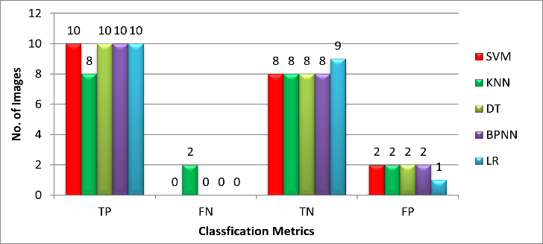
Fig. 10. Comparison of classifiers using TP, FN, TN and FP
Table 2. Analysis Report of SVM , KNN, LR, DT and BPNN
Classifiers | Accuracy | Sensitivity | Specificity | Precision | F1-Score
SVM | 0.9000 | 1.0000 | 0.8300 | 0.8000 | 0.9091
KNN | 0.8000 | 0.8000 | 0.8000 | 0.8000 | 0.8000
DT | 0.9000 | 1.0000 | 0.8000 | 0.8333 | 0.9091
BPNN | 0.9000 | 1.0000 | 0.8000 | 0.8333 | 0.9091
LR | 0.9500 | 1.0000 | 0.9000 | 0.9091 | 0.9524

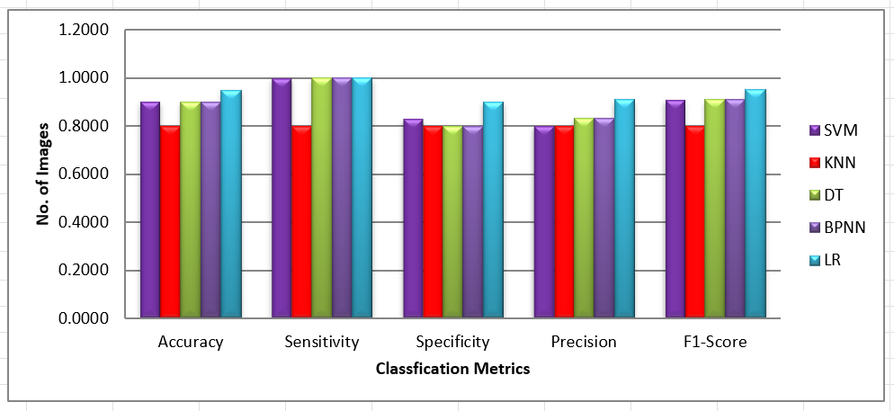
Fig. 11. Classification metrics of SVM, LR, KNN, DT and BPNN
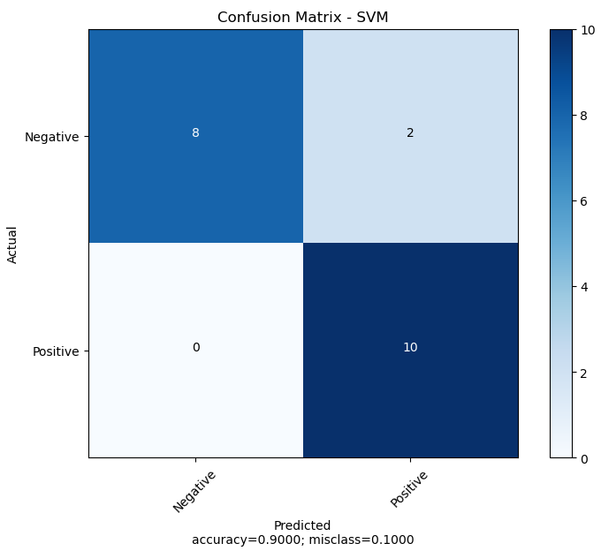
(a)
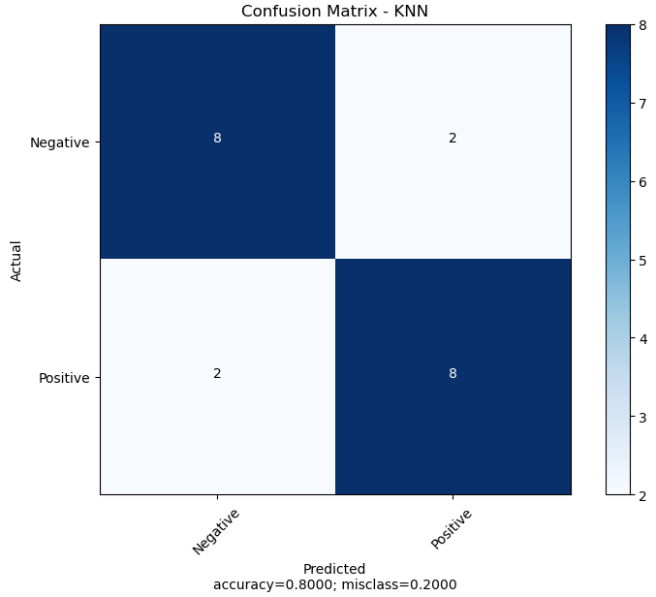
(b)
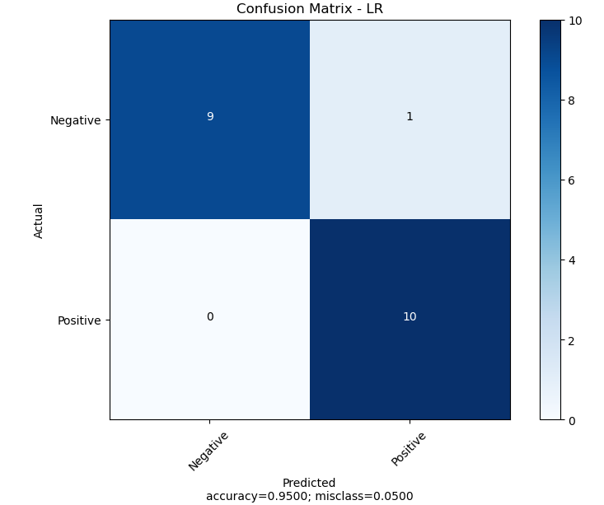
(c)
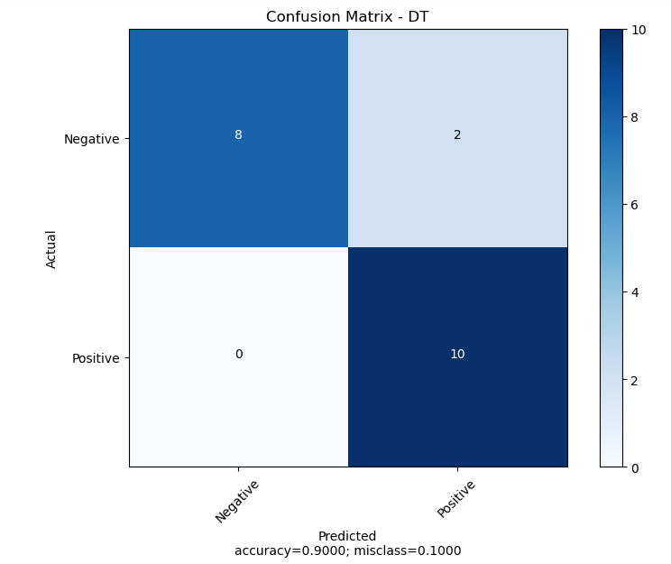
(d)
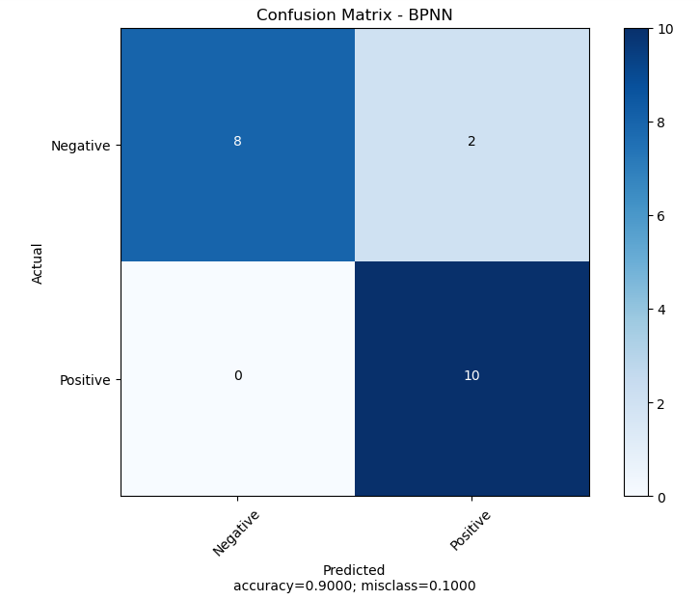
(e)

Fig. 12. (a) Confusion Matrix of SVM, (b) K-NN, (c) LR, (d) DT, (e) BPNN
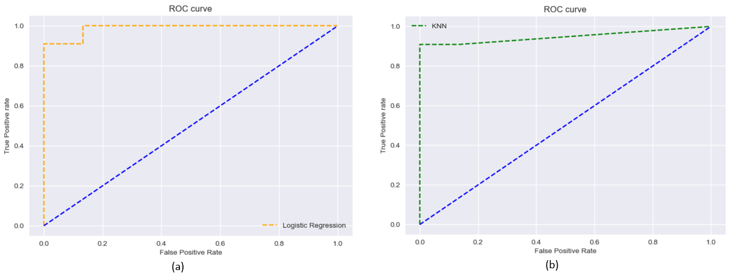
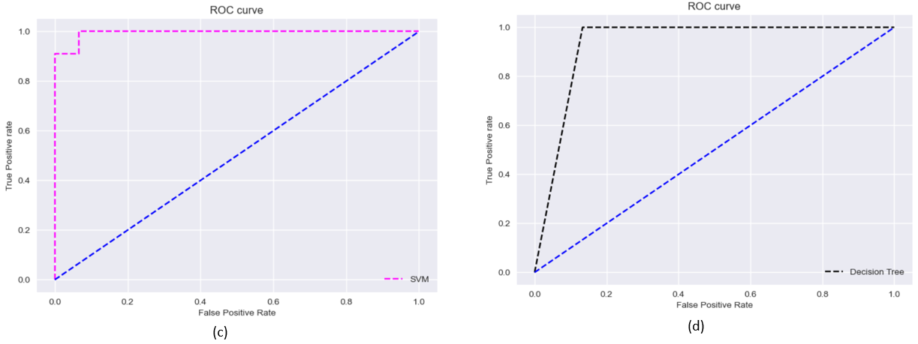
Fig. 13. (a) ROC Curve for SVM, AUC for 0.9878787878787879, (b) KNN, AUC for 0.9484848484848486,
(c) LR, AUC for 0.9939393939393939, (d) DT, AUC for 0.9333333333333333

- Conclusion
Human vision is affected by various retinal abnormalities. Pigment Epithelial Detachment is an ocular disease affects the people, particularly aged people. The presence of PED in the retina can be identified accurately using OCT imaging technique and early diagnosis of the disease reduce the related costs and recover the patient’s quality of life. In the proposed work, we used denoising, RPE layer segmentation, feature extraction and PED detection steps and we proposed four novel features such as MLH, MRH, MLDP and MRDP, and got satisfactory results. This model can be used to assists the doctor to identify and classify the PED presence in OCT images.
In this paper, the SVM , KNN, LR, DT classifiers were analysed using the unique features extracted from the OCT images to identify PED. And, also the machine learning algorithms were analysed with Artificial Neural Network such as Back Propagation Neural Network. Based on the comparison of machine learning classification algorithm, Logistic Regression (LR) yielded high accuracy than the other machine learning algorithms such as SVM, KNN, DT and BPNN. From the experimental results, the Logistic Regression (LR) produced 95% accuracy, 100% sensitivity, 90% specificity, 90% precision and 95% F1-score to detect PED. For particular abnormality-based PED, the efficiency of the suggested classifications method has to be evaluated. On the basis of which the real performance might be precisely and thoroughly analysed. The created method may also be real-time integrated with OCT devices on a detailed disorder-based investigation in order to seamlessly remark on the images that are providing as the system input. In future we will be compare the other machine learning classifications such as Random Forest, Naïve Bayes to detect the PED in OCT images.
Conflicts of interest
The authors declare no conflicts of interest.
References
Huang, D. et al, “Optical coherence tomography”, Science 254, 1178–1181 (1991).
Zayit-Soudry S et.al, “ A. Retinal pigment epithelial detachment”, Surv Ophthalmol 52, 227–243 (2007).
Lommatzsch A, Helmes B, Gutfleisch M and Spital G, “Serous pigment epithelial detachment in age-related macular degeneration comparison of different treatments”, Eye 23, 2163–2168 (2009).
Mrejen S, Sarraf D, Mukkamala S. K. and Freund K. B,” Multimodal imaging of pigment epithelial detachment a guide to evaluation”, Retina 33, 1735–1762 (2013).
Keane P. A. et. al, “Evaluation of age-related macular degeneration with optical coherence tomography”, Surv Ophthalmol 57, 389–414 (2012).
Masahiro Miura et.al , “ Evaluation of retinal pigment epithelium changes in serous pigment epithelial detachment in age related macular degeneration”, www.nature.com/scientificreports, 2021.
Poliner LS, Olk RJ, Burgess D, Gordon ME, “ Natural history of retinal pigment epithelial detachments in age-related macular degeneration”, Ophthalmology. 1986;93:543–551.
Pauleikhoff D, Loffert D, Spital G, et al., “Pigment epithelial detachment in the elderly. Clinical differentiation, natural course and pathogenetic implications”, Graefes Arch Clin Exp Ophthalmol. 2002;240:533–538.
Spaide RF, “Enhanced depth imaging optical coherence tomography of retinal pigment epithelial detachment in age-related macular degeneration”, Am J Ophthalmol. 2009;147:644 – 652.
Ojima Y, Hangai M, Sakamoto A, et al.,” Improved visualization of polypoidal vasculopathy lesions using spectral-domain optical coherence tomography”, Retina. 2009;29:52–59.
Smretschnig E, Krebs I, Moussa S, Ansari-Shahrezaei S, Binder S., “Cirrus OCT versus Spectralis OCT: differences in segmentation in fibrovascular pigment epithelial detachment”, Graefes Arch Clin Exp Ophthalmol. 2010;238:1693–1698.
Gupta V, Gupta P, Dogra MR, Singh R, Gupta A., “Morphological changes in the retinal pigment epithelium on spectral-domain OCT in the unaffected eyes with idiopathic central serous chorioretinopathy”, Int Ophthalmol. 2010;30:175–181.
Khanifar AA, Koreishi AF, Izatt JA, Toth CA., “Drusen ultrastructure imaging with spectral domain optical coherence tomography in age-related macular degeneration”,Ophthalmology 2008;115: 1883–1890.
Liakopoulos S, Ongchin S, Bansal A, et al., “Quantitative optical coherence tomography findings in various subtypes of neovascular age-related macular degeneration”, Invest Ophthalmol Vis Sci. 2008;49:5048 –5054.
Joeres S, Tsong J, Updike PG, et al., “Reproducibility of quantitative optical coherence tomography subanalysis in neovascular agerelated macular degeneration”, Invest Ophthalmol Vis Sci. 2007; 48:4300 – 4308.
Ahlers C, Simader C, Geitzenauser W, et al., “Automatic segmentation in three-dimensional analysis of fibrovascular pigment epithelial detachment using high-definition optical coherence tomography”, Br J Ophthalmol. 2008;92:197–203.
Penha FM, Rosenfeld PJ, Gregori G, et al., “Quantitative imaging of retinal pigment epithelial detachments using spectral-domain optical coherence tomography”, Am J Ophthalmol. Published online October 24, 2011.
Wilkins GR, Houghton OM, Oldenburg AL., “Automated segmentation of intrarentinal cystoid fluid in optical coherence tomography”, IEEE Trans Biomed Eng. 2013; 59 (4), pp. 1109–1114.
Wang C, Wang YX, Li Y,” Automatic choroidal layer segmentation using markov random field and level set method”, IEEE J. Biomed Heal Informatics. 2017; 21(6), pp. 1694–1702.
Niu S, Chen Q, L. de Sisternes, Rubin DL, Zhang W, Liu Q., “Automated retinal layers segmentation in SD-OCT images using dual-gradient and spatial correlation smoothness constraint”,ComputBiol Med. 2015; 5, pp. 116–128.
M. Anand, C. Jayakumari, “Automated Detection of Macular Hole in Optical Coherence Tomography Images using Depth-Check Algorithm”, International Journal of Engineering and Advanced Technology (IJEAT) ISSN: 2249 – 8958, Volume-9 Issue-1, October 2019.
M. Anand, C. Jayakumari,” A Novel Depth-Check Algorithm to Detect Macular Hole from Optical Coherence Tomography Images”, International Journal of Innovative Technology and Exploring Engineering (IJITEE) ISSN: 2278-3075, Volume-8 Issue-12, October 2019.
T.M. Sheeba and S. Albert Antony Raj ,” Analysis of Noise Removal Techniques on Retinal Optical Coherence Tomography Images”, (IJACSA) International Journal of Advanced Computer Science and Applications, Vol. 13, No. 9, 2022.
M. Anand, C. Jayakumari,” Automated detection of full thickness macular hole in optical coherence tomography images”, Journal of International Pharmaceutical Research, ISSN: 1674-0440.
M. Anand, C. Jayakumari,” A New Approach to Detect Macular Hole from Optical Coherence Tomography Images”, Indian Journal of Public Health Research & Development, July 2019, Vol.10, No. 7.
M Anand , T.M. Sheeba and A.S. Anshy Princella, “Detection of Retinal Diseases in Retinal Optical Coherence Tomography Images”, IEEE, ICEEICT 2023, pp. 2213-2219.
T.M. Sheeba and S. Albert Antony Raj and M. Anand, “Computational Intelligent Techniques and Analysis on Automated Retinal Layer Segmentation and Detection of Retinal Diseases”, IEEE, ICACCS 2023, 2023, pp. 2213–2219.
T.M. Sheeba and S. Albert Antony Raj and M. Anand, “ Analysis of Various Image Segmentation Techniques on Retinal OCT Images”, IEEE, ICAIS 2023, 2023, pp. 716–721.
T.M. Sheeba and S. Albert Antony Raj and M. Anand, “ Comparison of Machine Learning Algorithms for Pigment Epithelial Detachment Classification using Shape and Curvature Features”, IEEE, ICACRS 2022 - Proceedings, 2022, pp. 550–554.
T.M. Sheeba and S. Albert Antony Raj and M. Anand, “ Pigment Epithelial Detachment Detection: A Review of Imaging Techniques and Algorithms”, IEEE, ICACTA 2022, pp.1-8.
T.M. Sheeba and S. Albert Antony Raj and M. Anand, “Fluid Segmentation in Retinal OCT images with Pigment Epithelial Detachment”, IEEE, ICAEECI 2023.
Ana Maria,” Measures of Diagnostic Accuracy Basic Definitions”, EJIFCC. 2009; 19(4): 203-211.
RJ Hemalatha, V Vijayabaskarin, “Histogram Based Synovitis Scoring System Using Ultrasound Images of Rheumatoid Arthritis. Journal of Clinical and Diagnostic Research”, 2018; 12(8), pp. LC10-LC14.
Venkatraman and K M Sumathi, “A Study on Fluid based Retinal abnormalities Analysis from OCT Images using SVM Classifier”, ICACCS 2020 IEEE ,pp.86-89.
Guo J, Shi F, Zhu W, Chen H, Chen X., ”A framework for classification and segmentation of branch retinal artery occlusion in SD-OCT”, Prog Biomed Opt Imaging - Proc SPIE. 2016; 9784(7), pp. 3518–3527.
Hussain MA, Alauddin Bhuiyan, Andrew Turpin, Chi D. Luu, Theodre Smith R, Robyn H. Guymer, RamamohanraoKotagiri, “Automatic identification of pathology-distorted retinal layer boundaries using SDOCT imaging”, IEEE Trans Biomed Eng. 2017; 64(7), pp. 1638–1649.

